Case Report

National Gallery DC

### Tracy’s iPhone [2012-07-15-National-Gallery]

September 26th, 2020

**Laurén Alexa Gehringer**

# Table of Contents

Case Report

National Gallery DC

Tracy’s iPhone [2012-07-15-National-Gallery]

Table of Contents

Executive Summary

Equipment and Tools

Details of Tracy’s iPhone

Evidence to Establish Personas

Evidence relating to theft of valuable stamps

Evidence relating to defacement of museum art

Plot Timeline

Conclusion

Appendix A: Correspondence Evidence

Appendix B: WiFi and GPS Location Information

# 

# 

# Executive Summary

On January 21, 2016, Digitech Inc. was called in to assist the National Gallery, Washington D.C. (NGDC) case involving the conspiracy associated with the theft of valuable stamps and defacing of museums are at the NGDC. Forensics analyst Laurén Alexa Gehringer was tasked with collecting evidence in the case.

Tracy is a suspect in the aforementioned conspiracy. As part of the investigation, Tracy’s iPhone was taken into custody. Digitech, Inc. was tasked with investigating evidence relevant to the aforementioned conspiracy.

As described fully in the report, Digitech, Inc. discovered the evidence of the following:

* Tracy used the alias ‘Coral while her brother Pat used the alias ‘Perry’
* Tracy was financially motivated to accept bribes for a flash mob as well as steal stamps
* Email correspondence between Tracy’s private email and Pat containing National Gallery stamp letters
* Tracy planned to steal stamps with the assistance of her brother Pat, who attempted to coerce ‘King’ into helping with the heist
* Tracy leaked sensitive Gallery information to Carry as well as smuggled in a tablet in exchange for monetary bribes. Tracy seems unaware of any larger plot that Carry had in mind.

### Equipment and Tools

A combination of Kali Linux, Terminal, Autopsy, Nano, SQLite, and Microsoft Excel were utilized to uncover the evidence necessary to reveal the suspects behind the crimes.

# Details of Tracy’s iPhone

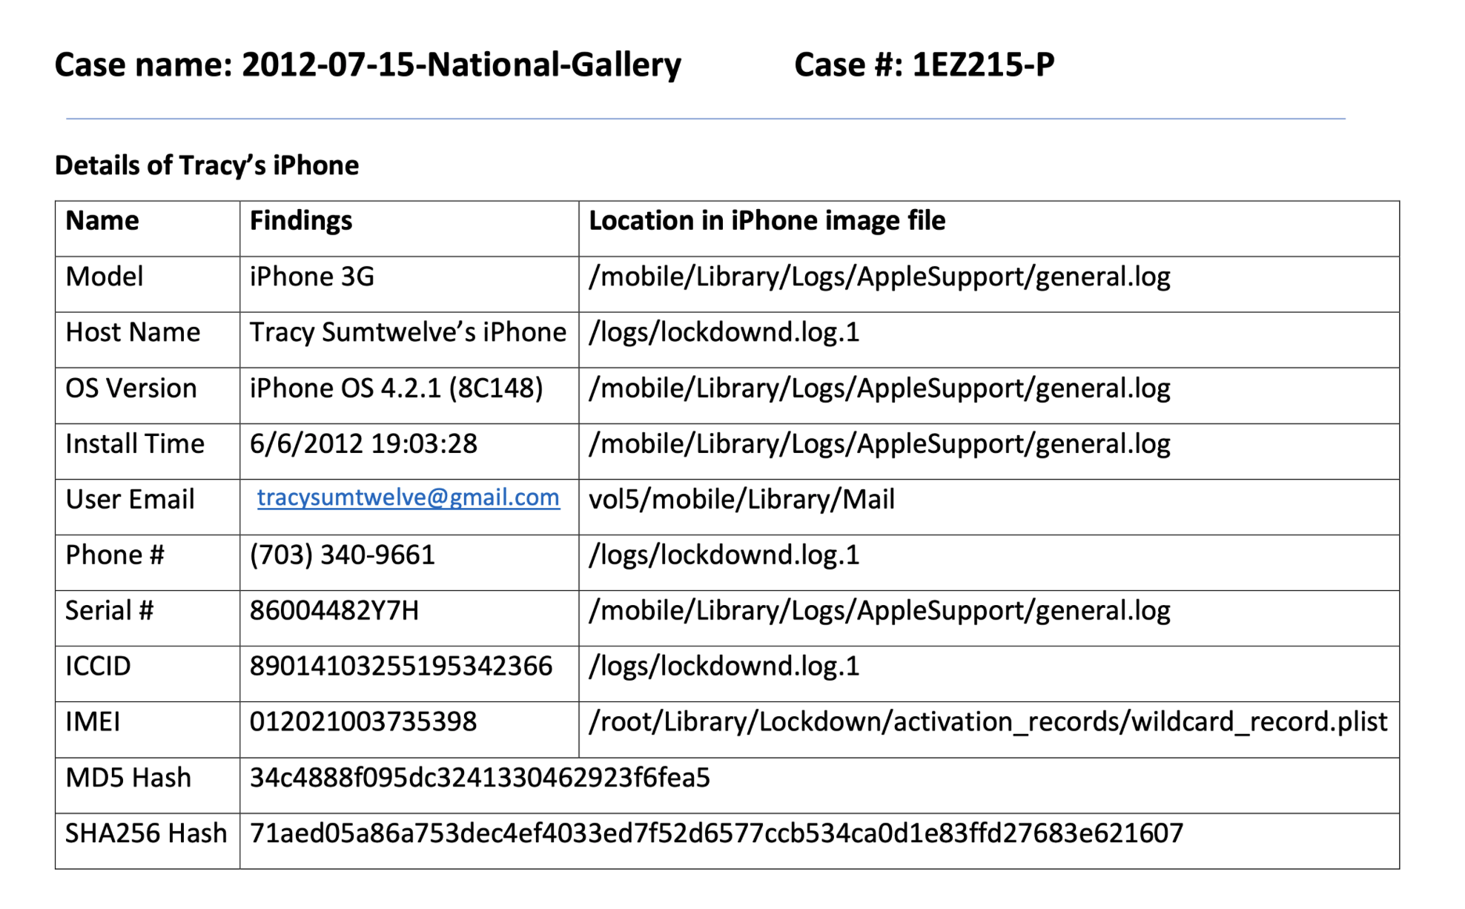

# Evidence to Establish Personas

This section establishes aliases, phone numbers, emails addresses associated with each person, and relationships between each individual.

**Tracy:**

Phone Number: (703) 340-9961

Personal Email: tracysumtwelve@gmail.com

Work Email: tracy.sumtwelve@nationalgallerydc.org

Relationship: Accused

**Pat:**

Phone Number: (571) 308-3236

Email: [patsumtwelve@gmail.com](mailto:patsumtwelve@gmail.com), perrypatsum@yahoo.com

Relationship: Tracy’s brother, a police detective

**Terry:**

Phone Number: (703) 829-6071

Relationship: Tracy’s daughter

**Joe:**

Email: joe.sum.twelve@gmail.com

Relationship: Tracy’s estranged husband

**Carry:**

Phone Number: (202) 725-2124

Email: carrysum2012@yahoo.com

Relationship: Acquaintance of Tracy, liaison between Tracy and Alex

**King:**

Email: throne1966@hotmail.com

Relationship: Coerced party, acquaintance of Pat

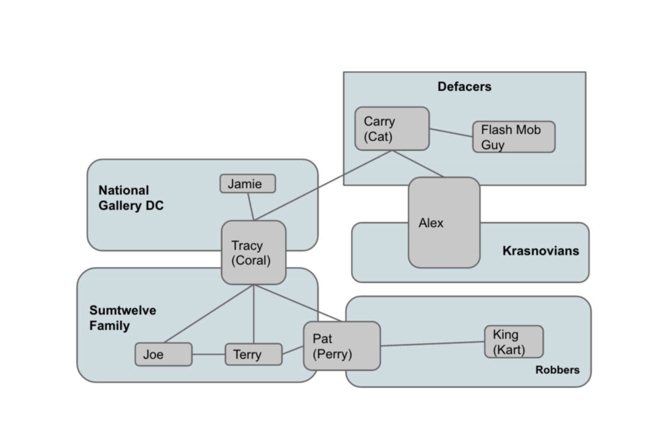

Carry was originally contacted by a Krasnovian named Alex who wanted to cause political unrest by defacing foreign art at the National Gallery. Carry then reached out to her acquaintance Tracy, a supervisor at the Gallery, and slipped her some money under the pretence of organizing a “flash mob.” It was the intent of Carry and Alex to sneak in Krasnovian thugs to deface art under the guise of flash mobbers. Meanwhile, Tracy (AKA Coral) intends to steal stamps from the Gallery with her brother Pat (AKA Perry) and the assistance of King. Tracy’s estranged husband learns of this plot from a keylogger he had installed on Tracy’s computer.

# Evidence relating to theft of valuable stamps

This sub-section provides details regarding the evidence found as it relates to the theft of valuable stamps.

Artifacts #18, 19, 23, and 32 show how Tracy discovered the foreign stamp collection exhibit, her conversations about them with Pat, and their subsequent interest in stealing the stamps due to their high value and low shipping costs. The plot continues in Artifact #32 and #33, which reveals Pat coercing a third party called King, a criminal on parole, into the heist by intimidation and blackmail. King assents with a list of necessary items, as seen in Artifact #40. Pat forwards the list to Tracy along with instructions on how to access the attachment over SMS, as shown in Artifact #40 and #41.

Tracy emails the compressed and encrypted Insurance documents regarding the stamp collection exhibit, marked as confidential, to Pat in Artifact #37. The file ‘Docs.zip’ contains 3 Stamp Insurance documents, which can be viewed in Appendix C.

Tracy’s iPhone also has multiple photos of the stamps mentioned in the Insurance documents. These photos can be viewed in Appendix D.

These Artifacts and Appendices reveal the plot to steal foreign stamps from the National Gallery, as conspired by Tracy and Pat.

# Evidence relating to defacement of museum art

This sub-section provides details regarding the evidence found as it relates to the defacement of museum art.

After Carry initially reaches out to Tracy over email, they meet for lunch at Bubba’s Grill; see Artifact #38. In the referenced email following the lunch meeting, Carry asks Tracy to sneak a tablet into the National Gallery for a “flash mob” event she had described previously, in exchange for monetary compensation.

As per artifacts #47 - 49: Tracy agrees to sneak in the tablet and to meet for a hand-off at 9. Carry additionally asks for information on a security shift change from Tracy in exchange for compensation, which Tracy again agrees to with the warning to be careful with the information.

As per artifacts #50 - 52: Tracy receives notifications from Google+ that Carry added her to a Circle, and that she had shared two albums with her. One of these notifications also contained the suggestion to add “Alex JFamEleven,” who was a part of Carry’s circles.

As per artifact #53: Tracy messages Carry to inquire about the “flash mob.” The provided evidence shows that while Tracy is guilty of leaking security information and smuggling in Carry’s tablet, she was not privy to the larger Krasnovian plot to deface foreign art.

# Plot Timeline

**6/19/20:** Tracy proposes she and Pat gain money through nefarious deeds, to which Pat accepts and suggests they begin using aliases. Pat sends instructions on how to install a Virtual Machine (VM).

**6/28/20:** Pat again suggests using aliases and they speak further on ways to make money. He tells Tracy he knows people that may assist them in their illegal deeds.

**6/29/20:** Tracy emails Pat that she has been viewing Insurance documents from the National Gallery in search of items to steal.

**7/2/20:** Tracy reveals she has found promising items in the Insurance documents that have a high value and a low shipping cost, indicating something small.

**7/3/20:** Tracy’s ex-husband Joe refuses to pay for Terry’s tuition expenses. This solidifies Tracy’s need to earn money in any way possible. Tracy emails Pat, revealing the valuable items are stamps. They begin doing research and finding an accomplice.

**7/5/20:** Carry reaches out to Tracy to have lunch. They set a date, time, and location.

**7/6/20:** Pat mentions he knows a man named King who can help with the heist. Pat coerces King to join the heist through blackmail. Tracy meets with Carry.

**7/9/20:** Carry emails Tracy to thank her for the lunch and asks her to help sneak in a tablet into the Gallery for the purpose of a “flash mob.”

**7/10/20:** Tracy agrees to smuggle the tablet for compensation. King agrees to help with the stamp heist and sends a list of items he will require.

**7/11/20:** Carry confirms a meeting to hand off the tablet the next day, and also requests sensitive security shift change information from Tracy, which Tracy agrees to for more money.

# Conclusion

Evidence found on Tracy’s iPhone indicated the following:

● Tracy was using the alias Coral and Pat was using the alias Perry

* ● Tracy’s main motivation for planning the stamp heist, smuggling the tablet, and leaking National Gallery security information was financial gain.
* ● Tracy emailed National Gallery DC stamp letters to her personal email account and to Pat
* ● Tracy planned to steal stamps with Pat and the assistance of King
* ● Tracy knew that Pat coerced someone named King to help with the heist

● Tracy leaked sensitive security information about the National Gallery to Carry.

* ● Tracy helped Carry smuggle a tablet into the Gallery.
* ● Tracy did not know about the larger Krasnovian plot to deface foreign art.

# Appendix A: Correspondence Evidence

This subsection will provide an amalgamation of the email and SMS corresponce evidence.

### 

|  |  |  |  |  |
| --- | --- | --- | --- | --- |
| Master Timeline of NGDC | | | | |
| Artifact # | Timestamp | Header Information | Key Information | Evidence Location |
| 1 | 6/12/2012 20:04:50 | F: (650) 887-0260  T: Tracy | Duration: 20 seconds | CALL |
| 2 | 6/12/2012 20:52:14 | F: (703) 829-6191  T: Tracy | Duration: 56 seconds | CALL |
| 3 | 6/12/2012 21:25:04 | F: Pat  T: Tracy | Pat asks Tracy about her plans for the weekend | SMS |
| 4 | 6/13/2012 16:29:13 | F: Tracy  T: Pat | Tracy calls Pat, no response | CALL |
| 5 | 6/13/2012 17:30:28 | F: Terry  T: Tracy | “I'm going out with dad after school for pizza! Thought I'd let you know if you planned to cook. T” | SMS |
| 6 | 6/13/2012 18:30:38 | F: Tracy  T: Pat | Tracy replies to Pat, states that she has no big plans and asks about his own plans | SMS |
| 7 | 6/13/2012 18:33:46 | F: Tracy  T: Terry | “Ok, sounds good.” | SMS |
| 8 | 6/19/2012 20:06:33 | F: patsumtwelve@gmail.com  T: tracysumtwelve@gmail.com  Subject: Paris Speak and answer | Pat emails Tracy. He accepts her proposal and asks her to email using her alias | Mailbox Data Structure |
| 9 | 6/19/2012 20:26:47 | F: perrypatsum@yahoo.com  T: tracysumtwelve@gmail.com  Subject: Look me up sometime | Pat emails Tracy asking her to utilize her alias in further communications. | Mailbox Data Structure |
| 10 | 6/19/2012 21:38:59 | F: perrypatsum@yahoo.com  T: coralbluetwo@hotmail.com  Subject: Crazydave by the VMs Attachment: Crazydave1.mp3 | Email Thread: Crazydave by the VMs  Pat emails Tracy instructions to install a Virtual Machine (VM) within an audio file. | Mailbox Data Structure |
| 11 | 6/19/2012 21:39:34 | F: perrypatsum@yahoo.com  T: coralbluetwo@hotmail.com  Subject: Re: ??? | Pat replies to Tracy, confirms that he is in receipt of her emails. | Mailbox Data Structure |
| 12 | 6/21/2012 17:43:15 | F: perrypatsum@yahoo.com  T: coralbluetwo@hotmail.com  Subject: Re: Crazydave by the VMs | Email Thread: Crazydave by the VMs  Pat replies to Tracy on an email thread about VM installation, sstating she should “listen” to other songs as well. Tracy then confirms that the instructions in the audio file helped her. | Mailbox Data Structure |
| 13 | 6/22/2012 17:34:26 | F: (571) 245-8517  T: Tracy | Missed call from (571) 245-8517 | CALL |
| 14 | 6/28/2012 19:31:33 | F: perrypatsum@yahoo.com  T: coralbluetwo@hotmail.com  Subject: Whats going on | Email Thread: Whats going on  Pat emails Tracy and asks her to only communicate using their chosen aliases and the VM setup to be safer going forward. He also hints they may have to act in a riskier or illegal way to ease their financial hardships. He says that a few of his workplace friends were familiar with the risky/illegal trades and would inform her should something pop-up; in the meantime they should keep discussing ideas. | Mailbox Data Structure |
| 15 | 6/29/2012 14:21:56 | F: perrypatsum@yahoo.com  T: coralbluetwo@hotmail.com  Subject: Re: Whats going on | Email Thread: Whats going on  This email thread continues as Pat and Tracy discuss money making ideas. Tracy says she will keep her eyes open for opportunities, and urges Pat to look into riskier opportunities as well: she needs money for her daughter Terry’s tuition.  Tracy is paying attention to documents, like insurance papers, so that she could identify something of potential. Pat assures that he will make something happen although he is nervous because IA has been sniffing around. | Mailbox Data Structure |
| 16 | 6/29/2012 14:31:36 | F: perrypatsum@yahoo.com  T: tracysumtwelve@gmail.com  Subject: hey sis | Pat emails Tracy addressing her as ‘sister’ and enquires about Terry. Asks her to check in with Coral with whom he has been planning some things. He also suggests all of them going together for dinner as friends.  He asks Tracy to check in with Coral.  Possible misdirection attempted by referring to Coral as a third person in the narrative. | Mailbox Data Structure |
| 17 | 6/29/2012 15:21:35 | F: perrypatsum@yahoo.com  T: coralbluetwo@hotmail.com  Subject: Re: Whats going on | Email Thread: Whats going on  Pat replies to the email thread about Tracy’s concern about IA. Earlier email in the thread Tracy says that although nothing interesting has turned up yet she expects something soon. Pat mentions that they can certainly get the job done if something like what they had earlier discussed occurs. | Mailbox Data Structure |
| 18 | 7/2/2012 16:13:18 | F: perrypatsum@yahoo.com  T: coralbluetwo@hotmail.com  Subject: Re: Some good news | Email Thread: Some good news  Tracy emails Pat and mentions an interesting upcoming foreign exhibit whose paperwork indicates it may be a big deal.  Pat replies back feeling hopeful about this being the opportunity they were looking for. | Mailbox Data Structure |
| 19 | 7/2/2012 20:00:31 | F: perrypatsum@yahoo.com  T: coralbluetwo@hotmail.com  Subject: Re: Some good news | Email thread: Some good news  Following up on the earlier email about the exhibit, Tracy mentions the prior foreign exhibit is worth a lot of money, and shipping costs were also very low. Pat replies, saying that may mean the exhibit is small objects, which would be beneficial. | Mailbox Data Structure |
| 20 | 7/3/2012 13:29:37 | F: joe.sum.twelve@gmail.com  T: tracysumtwelve@gmail.com  Subject: Re: Regarding Terry | Email Thread: Regarding Terry  Tracy emails her ex-husband Joe asking whether he could help her with Terry’s tuition this year, as it is expensive.  Joe replies that he won’t pay Terry’s tuition if she is not living with him. | Mailbox Data Structure |

### 

|  |  |  |  |  |
| --- | --- | --- | --- | --- |
| 21 | 7/3/2012 13:41:51 | F: Tracy  T: Terry | Tracy messages Terry regarding a school change, as Prufock tuition is too expensive. | SMS |
| 22 | 7/3/2012 14:04:32 | F: Terry  T: Tracy | Terry replies to Tracy’s inquiry about a school change, stating she would rather just stay with her father to continue attending Prufrock | SMS |
| 23 | 7/3/2012 14:53:04 | F: perrypatsum@yahoo.com  T :coralbluetwo@hotmail.com  Subject: Re: Some good news | Email Thread: Some good news  Tracy emails Pat revealing the foreign exhibit is a collection of rare and highly valuable stamps, and that it seems like the job they’ve been looking for. Pat asks her to collect as much information as possible about the exhibit and that he would look into options for pulling off the heist. | Mailbox Data Structure |
| 24 | 7/5/2012 15:51:31 | F: carrysum2012@yahoo.com  T: tracysumtwelve@gmail.com  Subject: Long time no see... | Email Thread: Long time no see…  Carry reaches out to Tracy asking her if they could meet-up for lunch and suggests “this Friday.” She also mentions that she saw Tracy wasn’t doing well lately on Facebook. | Mailbox Data Structure |
| 25 | 7/5/2012 18:18:23 | F: Carry  T: Tracy | Carry sets up a meeting time of 1pm and location at Bubba’s Grill | SMS |
| 26 | 7/5/2012 18:20:26 | F: Tracy  T: Carry | Tracy confirms time and location of meeting | SMS |
| 27 | 7/6/2012 15:02:19 | F: Tracy  T: Pat | Tracy requests Pat call her | SMS |
| 28 | 7/6/2012 15:08:37 | F: Pat  T: Tracy | Pat indicates he is busy and suggests he call later | SMS |
| 29 | 7/6/2012 15:11:54 | F: Tracy  T: Pat | Tracy urges the matter is important and insists Pat call her as soon as possible | SMS |

### 

|  |  |  |  |  |
| --- | --- | --- | --- | --- |
| 30 | 7/6/2012 15:13:31 | F: Pat  T: Tracy | Pat concedes and indicates he will call in 5 minutes | SMS |
| 31 | 7/6/2012 15:18:50 | F: Pat  T: Tracy | Pat calls Tracy. The call lasts 4 minutes and 4 seconds | CALL |
| 32 | 7/6/2012 15:27:51 | F: patsumtwelve@gmail.com  T: tracysumtwelve@gmail.com  Subject: Re: Good News | Email Thread: Good News  Tracy emailed Pat saying that she spoke with “Coral” and that Coral had some great news that Pat should talk to her about. Pat replies that he knows a guy named King. | Mailbox Data Structure |
| 33 | 7/6/2012 15:49:31 | F: patsumtwelve@gmail.com  T: throne1966@hotmail.com  Cc:coralbluetwo@hotmail.com  Subject: can't pass up | Pat emails King with Tracy in cc, offering a lucrative position in a heist at the National Gallery, along with a threat to comply or else he would put King’s parole in jeopardy. | Mailbox Data Structure |
| 34 | 7/6/2012 16:27:16 | F: Carry  T: Tracy | Carry indicates she has a table inside the restaurant | SMS |
| 35 | 7/6/2012 16:27:50 | F: Tracy  T: Carry | Tracy confirms she will be there | SMS |
| 36 | 7/6/2012 17:59:24 | F: patsumtwelve@gmail.com  T: tracysumtwelve@gmail.com  Subject: Re: Good News | Email Thread: Good News  Tracy suggests they (King, Tracy and Pat) should hang out sometime.  Pat emails Tracy with account login information for: coralblue@hotmail.com  Password: legalBee | Mailbox Data Structure |
| 37 | 7/9/2012 14:44:11 | F: tracysumtwelve@gmail.com  T: coralbluetwo@hotmail.com  Subject: things | The email contains compressed and encrypted ZIP folders.  documents.zip is a compressed ZIP folder containing 3 insurance documents related to stamps.  docs.zip is an encrypted ZIP folder containing 3 insurance documents related to stamps. | /mobile/Librar y/Mail/POP- coralbluetwo @hotmail.com @pop3.live.co m/INBOX.mbo x/Messages/8 A3BD06F- CDB1-4453- 9C69- 77E06823F2A E.emlx |
| 38 | 7/9/2012 18:18:47 | F: carrysum2012@yahoo.com  T: tracysumtwelve@gmail.com  Subject: Re: Long time no see.. | Email Thread: Long time no see...  Tracy thanks Carry for the lunch. Carry asks Tracy for help sneaking in a tablet for a “flash mob” event they had spoken earlier about. Carry suggests that Tracy would be compensated in some way for the help. | Mailbox Data Structure |

### 

|  |  |  |  |  |
| --- | --- | --- | --- | --- |
| 39 | 7/10/2012 13:48:40 | F: carrysum2012@yahoo.com  T: tracysumtwelve@gmail.com  Subject: Re: Long time no see.. | Email Thread: Long time no see…  Tracy agrees to help Carry sneak in the tablet and asks when Carry would like to take a look at the Gallery. Carry replies saying that this would be a big help and asks if she could come “around 9 tomorrow.” | Mailbox Data Structure |
| 40 | 7/10/2012 15:24:57 | F: patsumtwelve@gmail.com  T: coralbluetwo@hotmail.com  Subject: Fwd: can't pass up  Attachment: needs.txt | Email Thread: can’t pass up  King agrees to help with the heist and forwards a document containing a list of required equipment. The attached document is saved as a ‘txt’ file. Pat forwards that email to Tracy. | /mobile/Librar y/Mail/POP- coralbluetwo @hotmail.com @pop3.live.co m/INBOX.mbo x/Messages/9 F0508B8- 04FB-490E- A7F0- 3E23B0E7C5 9B.emlx |
| 41 | 7/10/2012 15:26:19 | F: Pat  T: Tracy | Pat messages Tracy that attached document ‘needs.txt’ needs to be changed to a .pdf file, and to relay that to “Coral” | SMS |
| 42 | 7/10/2012 15:58:04 | F: Tracy  T: Pat | Tracy acknowledges the email containing the needs.txt document as well as the previous text message | SMS |
| 43 | 7/10/2012 16:37:09 | F: Tracy  T: Pat | Tracy attempts to share a location with Pat over MMS message, but the correspondence fails.  Location: 2600-2700 24th Rd S, Arlington, VA 22206 | SMS |
| 44 | 7/10/2012 17:18:38 | F: Tracy  T: Terry | Tracy messages Terry for lunch | SMS |
| 45 | 7/10/2012 18:19:24 | F: Tracy  T: Terry | Tracy messages Terry that she is back at work | SMS |
| 46 | 7/10/2012  18:58:24 | F: Terry  T: Tracy | Terry states she is busy and suggests meeting on the weekend if Joe isn’t busy | SMS |

### 

|  |  |  |  |  |
| --- | --- | --- | --- | --- |
| 47 | 7/11/2012  12:41:45 | F: Carry  T: Tracy | Carry states she is almost to the National Gallery | SMS |
| 48 | 7/11/2012  12:49:08 | F: Tracy  T: Carry | Tracy replies to meet out front, and she will take the tablet inside the Gallery | SMS |
| 49 | 7/11/2012 17:06:19 | F: carrysum2012@yahoo.com  T: tracysumtwelve@gmail.com  Subject: Re: Long time no see... | Email Thread: Long time no see...  Tracy confirms the meeting at “9 tomorrow.”  Carry wants Tracy to give her information regarding shift changes of security. She suggests that Tracy would be well compensated for the information.  Tracy confirms that she will give the security information to Carry in exchange for money, but asks Carry to be careful with it.  Carry replies asking Tracy not to worry and says “It will be gun”. | Mailbox Data Structure |
| 50 | 7/11/2012 19:28:53 | F: "Google+" <noreply- 5dd47ca1@plus.google.com>  T: tracysumtwelve@gmail.com  Subject: Carry Carsumtwotwelve added you on Google+ | Notification from Google+ informing Tracy that Carry has added her to a circle (group). The notification also suggests she may know Alex JFamEleven, who is in Carry’s circles. | Mailbox Data Structure |
| 51 | 7/11/2012 23:22:03 | F: "Carry Carsumtwotwelve (Google+)" <replyto- 748d3d22@plus.google.com>  T: tracysumtwelve@gmail.com    Subject: Carry Carsumtwotwelve is sharing with you on Google+ | Notification from Google+ informing Tracy that Carry had shared an album. | Mailbox Data Structure |
| 52 | 7/12/2012 16:12:07 | F: "Carry Carsumtwotwelve (Google+)" <replyto- 748d3d22@plus.google.com>  T: tracysumtwelve@gmail.com  Subject: Carry Carsumtwotwelve is sharing with you on Google+ | Notification from Google+ informing Tracy that Carry had shared an album. | Mailbox Data Structure |
| 53 | 7/12/2012 17:06:45 | F: Tracy  T: Carry | Tracy questions carry about the flash mob | SMS |
| 54 | 7/12/2012 18:03:51 | F: carrysum2012@yahoo.com  T: tracysumtwelve@gmail.com  Subject: Re: Long time no see... | Email Thread: Long time no see…  Tracy emailed Carry asking her what she meant by “It will be gun”.  Carry replies saying that it was a typographical error and she meant “It will be fun”. | /mobile/Librar y/Mail/POP- coralbluetwo @hotmail.com @pop3.live.co m/INBOX.mbo x/Messages/3896FC6F-A083-4D39-B0A2-CE68368D44CA.emlx |

### 

# Appendix B: WiFi and GPS Location Information

This subsection will provide a complete log of all known WiFi and GPS location findings

### 

|  |  |  |  |  |
| --- | --- | --- | --- | --- |
| Location Information | | | | |
| Artifact # | Timestamp | Header Information | Body | Map Screenshot |
| 1 | 6/13/2012  19:01:21 | CellLocation | Location: Virginia Tech Research Center - Arlington  (900 N Glebe Rd, Arlington, VA 22203) | Location Data |
| 2 | 6/13/2012  19:01:22 | WifiLocation | Location: Virginia Tech Research Center - Arlington  (900 N Glebe Rd, Arlington, VA 22203) | Location Data |
| 3 | 6/13/2012  19:04:03 | WifiLocation | Location: Virginia Tech Research Center - Arlington  (900 N Glebe Rd, Arlington, VA 22203) | Location Data |
| 4 | 6/23/2012  17:12:16 | CellLocationLocal | Location: 22 West A Condominium  1177 22nd St NW  Washington, DC 20037 | Location Data |
| 5 | 7/2/2012  16:19:23 | CellLocation | Location: Virginia Tech Research Center - Arlington  (900 N Glebe Rd, Arlington, VA 22203) | Location Data |
| 6 | 7/2/2012  16:19:24 | WifiLocation | Location: Virginia Tech Research Center - Arlington  (900 N Glebe Rd, Arlington, VA 22203) | Location Data |
| 7 | 7/3/2012  13:42:42 | WifiLocation | Location: Virginia Tech Research Center - Arlington  (900 N Glebe Rd, Arlington, VA 22203) | Location Data |
| 8 | 7/5/2012  16:32:46 | CellLocation | Location: Virginia Tech Research Center - Arlington  (900 N Glebe Rd, Arlington, VA 22203) | Location Data |
| 9 | 7/5/2012  16:32:47 | WifiLocation | Location: Virginia Tech Research Center - Arlington  (900 N Glebe Rd, Arlington, VA 22203) | Location Data |
| 10 | 7/5/2012  16:42:27 | CellLocationLocal | 226 Upshur St NW  Washington, DC 20011 | Location Data |
| 11 | 7/8/2012  16:39:10 | CellLocationLocal | Location: National Gallery of Art Sculpture Garden | Location Data |
| 12 | 7/10/2012  16:31:10 | CellLocation | Location: 2600-2700 24th Rd S, Arlington, VA 22206 | Location Data |
| 13 | 7/10/2012  16:31:12 | WifiLocation | Location: 2600-2700 24th Rd S, Arlington, VA 22206 | Location Data |
| 14 | 7/10/2012  16:36:51 | Maps Directions | Location: 2600-2700 24th Rd S, Arlington, VA 22206 to 1521 North Quaker Lane, Alexandria, VA 22302 (CVS Pharmacy) | /mobile/Library/Maps/Directions.plist |
| 15 | 7/10/2012  16:44:59 | CellLocation | 1521 North Quaker Lane, Alexandria, VA 22302 (CVS Pharmacy) | Location Data |
| 16 | 7/10/2012  16:45:01 | WifiLocation | 1521 North Quaker Lane, Alexandria, VA 22302 (CVS Pharmacy) | Location Data |
| 17 | 7/10/2012  16:46:29 | WifiLocation | 1521 North Quaker Lane, Alexandria, VA 22302 (CVS Pharmacy) | Location Data |
| 18 | 7/10/2012  16:47:12 | CellLocationLocal | 1521 North Quaker Lane, Alexandria, VA 22302 (CVS Pharmacy) | Location Data |
|  |  |  |  |  |
|  |  |  |  |  |

# Appendix C: Stamp Insurance Documents

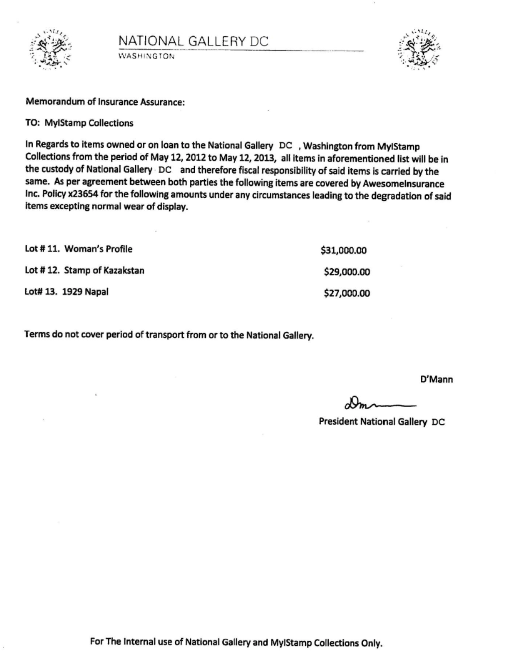

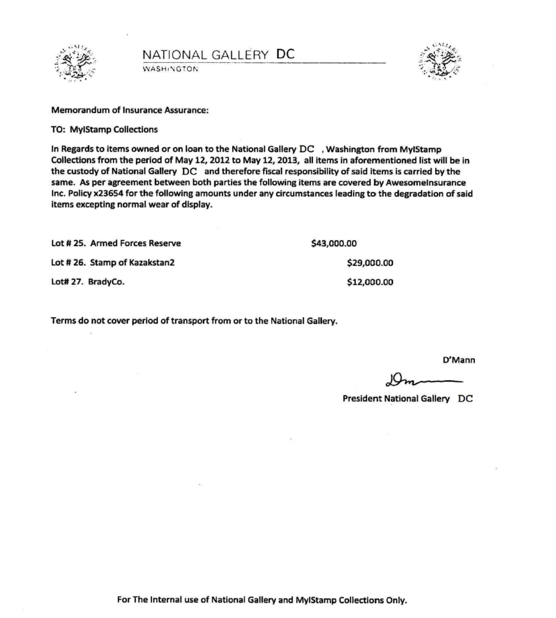

# Appendix D: Stamp Photos

Taken 7/8/2012

